INTRODUCTION
Java provides different classes and data structures to store, manage and process data efficiently. This assignment focuses on strings, collections, generics, comparison techniques and queue management. The main purpose of this assignment is to understand how different Java concepts work and compare their performance under different conditions. Each question includes implementation, experimentation, complexity analysis and evaluation.
OBJECTIVES
- To understand the difference between String, StringBuilder and StringBuffer.
- To compare ArrayList, LinkedList and ArrayDeque.
- To understand the equals() and hashCode() contract.
- To analyse different Map implementations.
- To implement Generics, Comparable and Comparator.
- To understand Queue and PriorityQueue operations.
- To identify performance limitations and develop improved solutions.

Q1 – BUILDING TEXT UNDER LOAD: STRING, STRINGBUILDER OR STRINGBUFFER
1. Aim
To compare String, StringBuilder and StringBuffer while generating railway e-tickets and identify the most suitable approach based on execution time and memory usage.
2. Introduction
Java provides three different approaches for handling text.
- String: String objects are immutable. Once created, their values cannot be changed.
- StringBuilder: It is mutable and allows modification without creating a new object for every operation.
- StringBuffer: It is mutable and synchronized, making it suitable for shared operations involving multiple threads.
3. Implementation Approach
Three different approaches are implemented to generate railway tickets.
- Using String concatenation (+ operator).
- Using StringBuilder.
- Using StringBuffer.
Three workloads are considered:
- Workload 1: 1 ticket with 5 fields.
- Workload 2: 10,000 tickets with 50 fields each.
- Workload 3: 5,000 tickets with 100 fields each.
The execution time is measured using System.nanoTime(). Repeated executions are performed to calculate average execution time.
4. Experimental Results
Table 1: Execution Time Comparison

Workload | String (ms) | StringBuilder (ms) | StringBuffer (ms)
Workload 1
Workload 2
Workload 3
Table 2: Memory and Object Creation
Method | Intermediate Objects | Memory Usage
String
StringBuilder
StringBuffer
5. Analysis
String creates additional objects during repeated concatenation because it is immutable. StringBuilder modifies the existing buffer and reduces unnecessary object creation. StringBuffer provides synchronized methods but may have additional execution overhead.
The experimental results are used to identify the most efficient approach.
6. Design Decision
StringBuilder is recommended for generating individual e-tickets because it provides efficient text modification.
StringBuffer is suitable when multiple threads need to modify the same shared text buffer safely.
7. Complexity Analysis
- String concatenation inside a loop: O(n²) character copying in the general repeated-concatenation case.
- StringBuilder: O(n) total character processing for appending n fields, assuming suitable capacity.
- StringBuffer: O(n) total character processing, with synchronization overhead.
8. Alternative Concept
String.join(), StringJoiner and String.format() can also be used to generate ticket text. StringJoiner is useful when multiple fields need to be joined with a delimiter.
9. Conclusion
This experiment compares three Java text-handling approaches. StringBuilder is generally preferred for repeated text modifications, while StringBuffer is useful for synchronized shared operations. The final decision is based on measured execution time and memory usage.
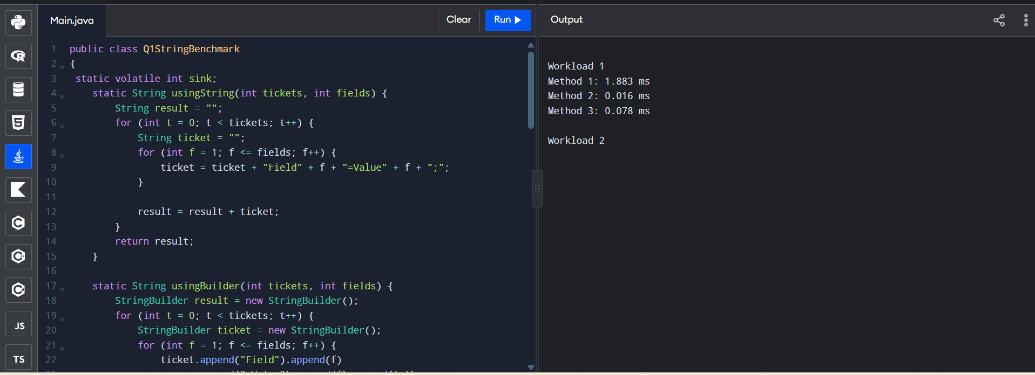
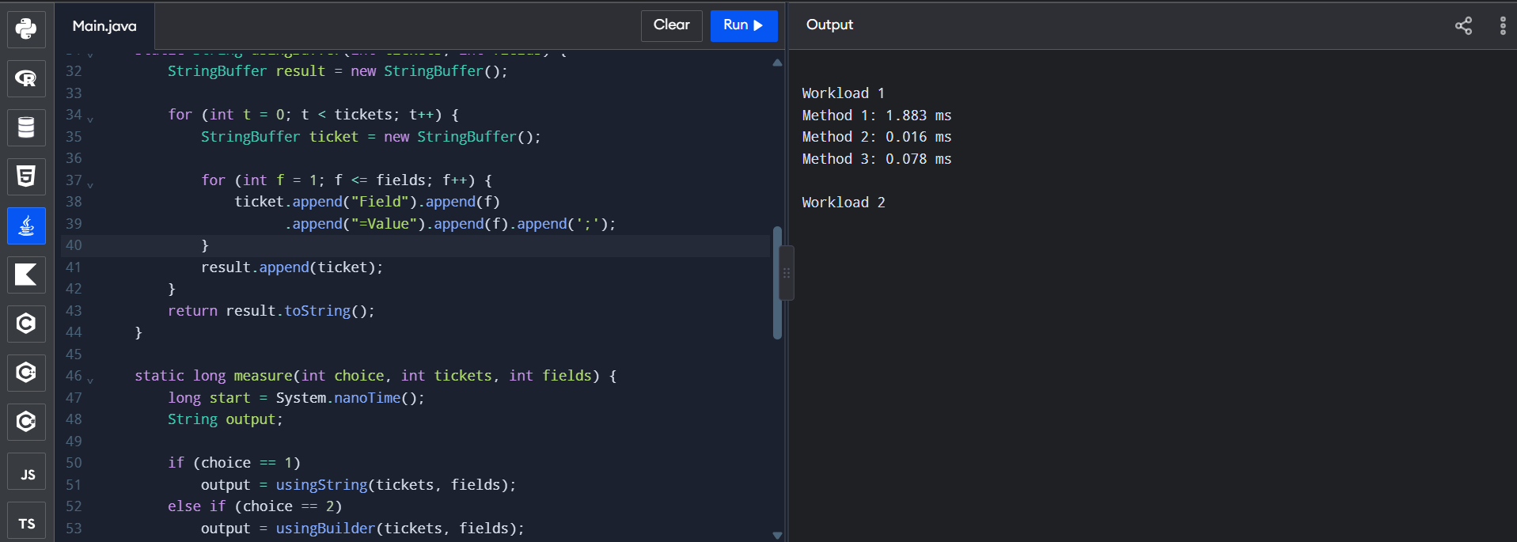
Q2 – WHEN IS ARRAYLIST AN APPROPRIATE ENGINEERING CHOICE?
1. Aim
To compare ArrayList, LinkedList and ArrayDeque for different playlist operations and identify the most appropriate collection.
2. Introduction
Java Collection Framework provides different data structures to store and manage elements.
- ArrayList: Uses a dynamic array and supports fast random access.
- LinkedList: Uses linked nodes and supports insertion and removal through known positions or iterators.
- ArrayDeque: Uses a resizable array and efficiently supports insertion and deletion at both ends.
3. Implementation Approach
A music playlist is used to test different collection operations.
The following operations are compared:
- Adding songs at the end.
- Inserting songs at the front.
- Inserting songs in the middle.
- Removing songs from the front and middle.
- Accessing the k-th song.
- Iterating through the entire playlist.
Three playlist sizes are considered:
- 1,000 songs.
- 10,000 songs.
- 100,000 songs.
4. Experimental Results
Table 1: Performance Comparison
Operation | ArrayList (ms) | LinkedList (ms) | ArrayDeque (ms)
Add at end
Insert at front
Insert in middle
Remove from front
Access k-th element
Full iteration
Table 2: Different Playlist Sizes
Playlist Size | ArrayList | LinkedList | ArrayDeque
1,000
10,000
100,000
5. Analysis
ArrayList provides fast random access because elements are stored in an array. LinkedList allows efficient insertion and deletion when the required node or iterator position is already available. ArrayDeque is suitable for operations performed at both ends.
For a playlist with frequent random access and adding songs at the end, ArrayList is a reasonable choice. For an Up Next queue with frequent insertion at both ends and removal from the front, ArrayDeque is more appropriate.
6. Complexity Analysis
Operation | ArrayList | LinkedList | ArrayDeque
Add at end | O(1) amortized | O(1) | O(1) amortized
Insert at front | O(n) | O(1) | O(1)
Insert in middle | O(n) | O(n) to locate, O(1) to link
Get k-th element | O(1) | O(n) | O(n)
Iterate | O(n) | O(n) | O(n)
7. Alternative Concept
A plain array can also store playlist songs. However, inserting or removing elements requires shifting other elements manually. This makes insertion and deletion more expensive compared with operations at the ends of suitable collection structures.
8. Conclusion
ArrayList is suitable for playlists that require frequent random access. LinkedList is useful when frequent insertion and deletion are performed through known positions. ArrayDeque is the better choice for the Up Next queue because it efficiently supports operations at both ends.

Q3 – ENGINEER THE HASHCODE-EQUALS CONTRACT
1. Aim
To understand the relationship between equals() and hashCode() and investigate how HashSet identifies duplicate student records.
2. Introduction
HashSet is a Java collection that stores unique elements. It uses hashCode() and equals() to identify duplicate objects.
- equals(): Checks whether two objects are logically equal.
- hashCode(): Returns an integer hash value used by hash-based collections.
If two objects are equal according to equals(), they must return the same hash code.
3. Implementation Approach
A Student class is created with registration number and student name.
Three experiments are performed:
Experiment 1: Normal Scans
Different students are added to HashSet.
Experiment 2: Duplicate Scans
The same registration number is added multiple times to identify duplicate entries when hashCode() is not correctly implemented.
Experiment 3: Additional Test
The registration number is modified after insertion to observe how changing a hash-related field affects HashSet operations.
4. Experimental Results
Experiment | Expected Size | Actual Size
Normal student records
Duplicate student records
Modified registration number
5. Complete the Code
The hashCode() method is implemented consistently with equals().
The following code is added inside the Student class:
6. Analysis
HashSet uses hashCode() to identify the bucket where an object should be stored. It then uses equals() to check whether an existing object is equal to the new object.If equals() is overridden without correctly overriding hashCode(), duplicate objects may appear in the HashSet.Changing a field used in hashCode() after insertion can make the object difficult to locate in the collection.
7. Alternative Concept
TreeSet can be used with a Comparator based on registration number. HashMap can also be used by storing registration numbers as keys.
8. Complexity Analysis
Collection | Average Lookup/Insertion | Space
HashSet | O(1) | O(n)
TreeSet | O(log n) | O(n)
HashMap | O(1) | O(n)
9. Conclusion
The experiment demonstrates the importance of implementing equals() and hashCode() correctly. A consistent implementation helps HashSet maintain unique student records and avoid duplicate entries.
Q4 – CHOOSING A MAP FOR A PHARMACY INVENTORY
1. Aim
To compare HashMap, TreeMap and LinkedHashMap for managing hospital pharmacy inventory.
2. Introduction
Map is an important interface in the Java Collection Framework. It stores information in key-value pairs.
The three Map implementations are:
- HashMap: Stores key-value pairs without guaranteeing iteration order.
- TreeMap: Stores keys in sorted order.
- LinkedHashMap: Maintains insertion order.
3. Implementation Approach
A pharmacy inventory system is created using medicine codes as keys and medicine details as values.
Three Map implementations are tested:
- HashMap.
- TreeMap.
- LinkedHashMap.
The following operations are performed:
- Adding medicines.
- Searching medicines by code.
- Updating stock.
- Displaying medicines in code order.
- Displaying medicines in insertion order.
Three different inventory sizes are considered:
- 1,000 medicines.
- 10,000 medicines.
- 50,000 medicines.
4. Experimental Results
Table 1: Lookup Performance
Number of Medicines | HashMap (ms) | TreeMap (ms) | LinkedHashMap (ms)
1,000
10,000
50,000
Table 2: Report Generation
Map Type | Code Order | Insertion Order
HashMap | No guarantee | No guarantee
TreeMap | Yes | No
LinkedHashMap | No | Yes
5. Analysis
HashMap provides average constant-time lookup and insertion operations.
TreeMap maintains sorted order using its keys and provides logarithmic-time basic operations.
LinkedHashMap maintains insertion order and provides average constant-time basic operations.
6. Complexity Analysis
Operation | HashMap | TreeMap | LinkedHashMap
put() | O(1) average | O(log n) | O(1) average
get() | O(1) average | O(log n) | O(1) average
Iteration | O(n) | O(n) | O(n)
7. Alternative Concept
A sorted array of medicines can be used with Arrays.binarySearch() to search for medicine codes.
- Searching: O(log n).
- Insertion: O(n).
- Code-order report: O(n).
- Storage: O(n).
8. Deployment Decision
HashMap is suitable when fast medicine lookup is the main requirement. TreeMap is suitable for reports that require sorted medicine codes. LinkedHashMap is suitable for maintaining insertion order.
Hashtable is generally not preferred in new Java code because modern alternatives provide more flexible collection handling.
9. Conclusion
The experiment compares three Map implementations and demonstrates that the correct choice depends on lookup speed and ordering requirements.
Q5 – DERIVE A GENERIC RANKING COMPONENT FROM A PRINCIPLE
1. Aim
To develop a reusable Java ranking component using Generics, Comparator and comparison techniques.
2. Introduction
Generics allow classes and methods to work with different data types while maintaining type safety.
Comparable and Comparator are used to define the ordering of objects.
- Comparable: Defines the natural ordering inside a class.
- Comparator: Defines custom ordering separately from the class.
- Generics: Allow reusable components to work with different object types.
3. Implementation Approach
A sports leaderboard is created to rank teams based on three conditions.
- Higher points receive higher priority.
- If points are equal, higher goal difference receives higher priority.
- If both are equal, team names are arranged alphabetically.
A generic Leaderboard<T> class is created to store and rank different types of objects.
4. Complete the Code
The ranking() method returns a sorted copy without modifying the original list.
The comparator is created using Comparator.comparing() and thenComparing().
Expected Output:
[Eagles(9,6), Bisons(9,4), Panthers(9,4), Cobras(6,1)]
5. Experimental Results
Test Case | Input Condition | Expected Result | Actual Result
Test 1 | Different points | Higher points first
Test 2 | Equal points | Higher goal difference first
Test 3 | Equal points and goal difference | Alphabetical order
Test 4 | Incorrect comparator | Identify faulty ranking
6. Analysis
The comparator first compares team points in descending order. If points are equal, it compares goal difference in descending order. Finally, it compares team names alphabetically. Bisons is ranked above Panthers because both teams have equal points and goal difference, but Bisons comes before Panthers alphabetically.
7. Alternative Concept
cccTeam can implement Comparable<Team> to define its natural ordering.Another approach is to use multiple stable sorting operations, starting with team name, followed by goal difference and points.However, Comparator is more reusable because different ranking rules can be created without changing the original class.
8. Complexity Analysis
- Comparator-based sorting: O(n log n).
- Comparable-based sorting: O(n log n).
- Three separate stable sorting operations: O(n log n) overall because three sorting passes are performed.
- Storage for n elements: O(n).
9. Conclusion
The experiment demonstrates how Generics and Comparator can be used to create reusable ranking systems. Comparator provides flexibility and allows different objects to be ranked using different rules.
Q6 – PRIORITY, ORDER AND FAIRNESS IN A QUEUE
1. Aim
To implement a hospital emergency triage system using PriorityQueue and compare its performance with other queue-based approaches.
2. Introduction
A queue follows the First In First Out (FIFO) principle. However, in a hospital emergency system, patients must be treated according to their severity. Priority Queue allows elements to be processed based on priority rather than only arrival order.
3. Implementation Approach
A hospital triage system is developed using Patient objects.
Each patient contains:
- Patient name.
- Severity level.
- Arrival time or arrival counter.
The priority rules are:
- Severity 1 patients are treated first.
- Lower severity numbers have higher priority.
- Patients with equal severity are treated in arrival order.
Approximately eight patients are added to the queue and processed according to their priority.
4. Expected Output
Meena(S1) Kumar(S1) Lata(S2) Ravi(S3) John(S3) Asha(S5)
5. Experimental Results
Table 1: Queue Performance
Number of Patients | Add Operation (ms) | Remove Operation (ms)
1,000
10,000
50,000
Table 2: Queue Comparison
Data Structure | Insertion | Removing Next Patient
PriorityQueue | O(log n) | O(log n)
Sorted LinkedList | O(n) | O(1)
Five FIFO Queues | O(1) | O(1)
6. Analysis
A normal Queue processes patients according to arrival order. It cannot directly provide priority based on severity.
Priority Queue arranges patients according to the comparator. An arrival counter is used to maintain the correct order when two patients have the same severity. Printing Priority Queue directly does not guarantee that elements appear in treatment order. Repeated polling displays them in priority order.
7. Starvation and Fairness
Starvation occurs when low-priority patients wait for a long time because higher-priority patients continue arriving. A fair solution is to increase the priority of patients who have waited beyond a specified time. This helps reduce excessive waiting.
8. Alternative Concept
A sorted LinkedList can maintain patients in priority order. However, insertion requires finding the correct position. Another approach is to maintain five FIFO queues, one for each severity level. The system checks the highest-priority non-empty queue first.
9. Conclusion
PriorityQueue provides an efficient solution for hospital triage systems. It processes patients based on severity and maintains arrival order among patients with equal severity.

Q7 – DIAGNOSE, REDESIGN AND VALIDATE
1. Aim
To identify a performance limitation in an existing Java implementation, redesign the solution and validate the improvement using experimental results.
2. Selected Problem
The String concatenation approach from Q1 is selected for redesign.
3. A. Diagnose the Bottleneck
The original implementation uses repeated String concatenation inside a loop. Since String is immutable, each concatenation creates a new String object. This increases object creation and character copying.
The main limitations are:
- Repeated object creation.
- Increased memory usage.
- Unnecessary character copying.
- Increased execution time for large workloads.
4. B. Define the Design Objective
The main objective is to reduce unnecessary object creation and improve text-generation performance.
The redesigned system should:
- Reduce execution time.
- Reduce intermediate String objects.
- Improve memory efficiency.
- Generate the same ticket output.
- Support larger workloads.
5. C. Design the Revised Solution
The original String concatenation approach is replaced with StringBuilder. StringBuilder maintains a mutable character buffer. Instead of creating a new String object after every concatenation, it modifies the existing buffer.
Original Design:
Ticket Generator → String Concatenation → Multiple Intermediate Objects → Final Ticket
Revised Design:
Ticket Generator → StringBuilder → Append Fields → Final Ticket
6. D. Predict Before Implementing
The redesigned solution is expected to perform better for large workloads.
Expected improvements include:
- Reduced intermediate object creation.
- Lower character-copying overhead.
- Reduced execution time.
- Better handling of large ticket data.
7. E. Implement and Validate the Redesign
Both original and redesigned implementations are executed using the same workloads.
Experimental Comparison
Workload | Original String (ms) | Redesigned StringBuilder (ms)
Workload 1
Workload 2
Workload 3
Memory Comparison
Implementation | Memory Usage
Original String
Redesigned StringBuilder
The results are compared to determine whether the redesign achieves the expected improvement.
8. F. Defend the Final Design
StringBuilder reduces unnecessary intermediate String creation and provides efficient text modification. The redesigned approach is suitable for generating large amounts of ticket information.
However, StringBuilder is not synchronized. If multiple threads modify the same shared buffer, synchronization or another thread-safe design is required. The original String approach may still be suitable for simple operations involving a small number of strings.
9. Conclusion
The design challenge demonstrates the importance of identifying performance limitations before selecting a solution. Replacing repeated String concatenation with StringBuilder provides a more efficient approach for large text-generation workloads. The final decision is supported by the experimental results.

